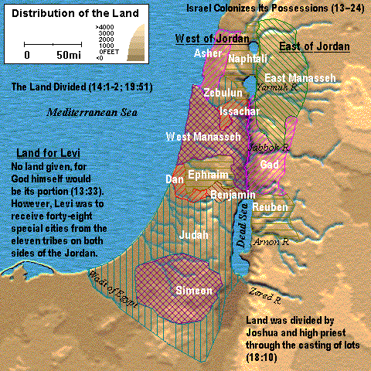
Distribution of the Land
Joshua 14-1-2; 19:51

